[哈尔滨医科大学知名团队论文图片重复](https://mp.weixin.qq.com/s?__biz=Mzg5MTg0MDc4NQ==&mid=2247493156&idx=1&sn=ca5a0cb81831db5c094f0500d1a8cc52&chksm=cefa98fb64caa78b52f8fb9e00f99f80466d3159ce34c059af9f8be5c305ea2ac9089006b943&scene=126&sessionid=1741972085)

原创  Fu[图片重复](javascript:void(0);)2025-03-10 09:19:00广东

**Human papillomavirus 16 E6 modulates the expression of host microRNAs in cervical cancer**

**Taiwanese Journal of Obstetrics and Gynecology (2015)**

**PMID:**26384051

**DOI:**10.1016/j.tjog.2014.06.007

**AUTHORS**

**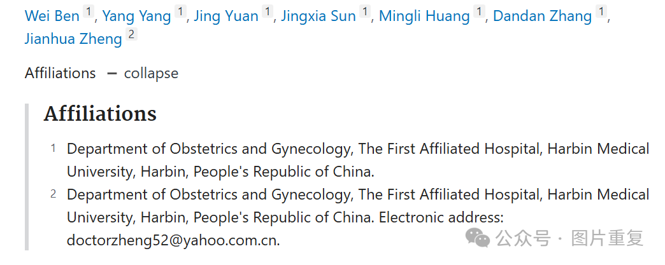  
#1Mycosphaerella Arachidis  5 month ago**

At least one blot is shared between apparently unrelated experiments in different papers. The other paper is here.

I think it would be in the interests of both teams of authors to figure out how this happened.

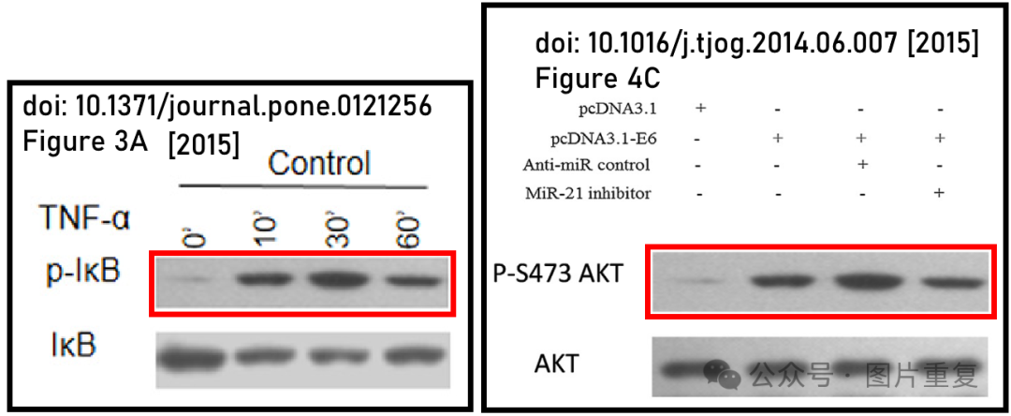Identified by ImageTwin.ai.

**#2Illex Illecebrosus 5 month ago**

#1

**Click here to see animation video based on issues reported above.**



Other animations available **here**. Link to the relevant PubPeer post is in the description. Please note that we are not making any judgements but simply visualising observations by others.

[#哈尔滨医科大学](https://mp.weixin.qq.com/mp/appmsgalbum?__biz=Mzg5MTg0MDc4NQ==&action=getalbum&album_id=3891923245447987207#wechat_redirect)[#图片重复](https://mp.weixin.qq.com/mp/appmsgalbum?__biz=Mzg5MTg0MDc4NQ==&action=getalbum&album_id=2546994047780667392#wechat_redirect)