[重庆医科大学知名附属医院论文图片重复](https://mp.weixin.qq.com/s?__biz=Mzg5MTg0MDc4NQ==&mid=2247493128&idx=1&sn=f1be4f12343db8ebadb7a62afff7a9ce&chksm=ce87d2945f9235ffcfa5db5f02cd4f008dfc18aa0aeb8580ddea3bd9a3ab3ba092eb939a3b99&scene=126&sessionid=1741972085)

原创  [图片重复](javascript:void(0);)2025-03-09 08:19:16广东

Long noncoding RNA MIR31HG inhibits hepatocellular carcinoma proliferation and metastasis by sponging microRNA-575 to modulate ST7L expression

**Journal of experimental & clinical cancer research : CR (2018)**

**PMID:**30176933

**DOI:**10.1186/s13046-018-0853-9

**AUTHORS**

**Shaoying Yan1,Zhenrong Tang2,Ke Chen1,Yuyang Liu1,Gangfeng Yu1,Qiuxu Chen1,Hao Dang1,Fengjiao Chen1,Jiaji Ling1,Liying Zhu1,Ailong Huang34,Hua Tang3**

**AFFILIATIONS**

1Key Laboratory of Molecular Biology for Infectious Diseases (Ministry of Education), Institute for Viral Hepatitis, Department of Infectious Diseases, The Second Affiliated Hospital, Chongqing Medical University, 1 Yi Xue Yuan Road, Chongqing, 400016, China.

2Department of Endocrine and Breast Surgery, The First Affiliated Hospital of Chongqing Medical University, Chongqing, China.

3Key Laboratory of Molecular Biology for Infectious Diseases (Ministry of Education), Institute for Viral Hepatitis, Department of Infectious Diseases, The Second Affiliated Hospital, Chongqing Medical University, 1 Yi Xue Yuan Road, Chongqing, 400016, China. .

4Collaborative Innovation Center for Diagnosis and Treatment of Infectious Diseases, Zhejiang University, Hangzhou, China. .

#### Author response

#### 10 month ago

**#1Hoya Camphorifolia**

**11 month ago**

* *[left]*

 Fig 4g,h.

* *[right]*

 Fig 6d,e.

* *below]*

 Fig 3B from "lncRNA XIST promotes the progression of laryngeal squamous cell carcinoma by sponging miR?144 to regulate IRS1 expression" (Cui et al 2020) **[retracted]**

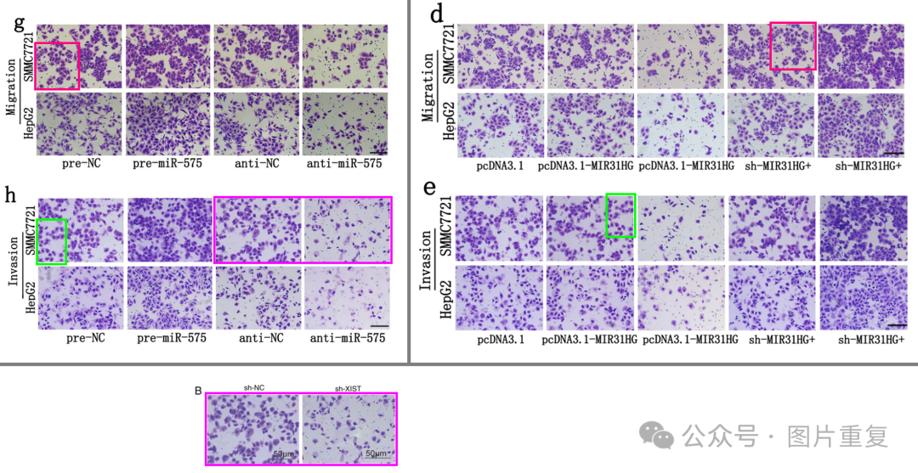

Two pairs of panels overlap, despite different labels. The later appropriation of two panels by Cui et al is of course not the fault of the present authors.

**#2Hoya Camphorifolia**

**11 month ago**

This is also an opportunity to alert the present authors to the subsequent acquisition of their images in "miR-654-5p Targets HAX-1 to Regulate the Malignancy Behaviors of Colorectal Cancer Cells" (Huang et al 2020).

*[left]* Fig 1e from Huang et al; from *[right]* the present Fig 2d/e.

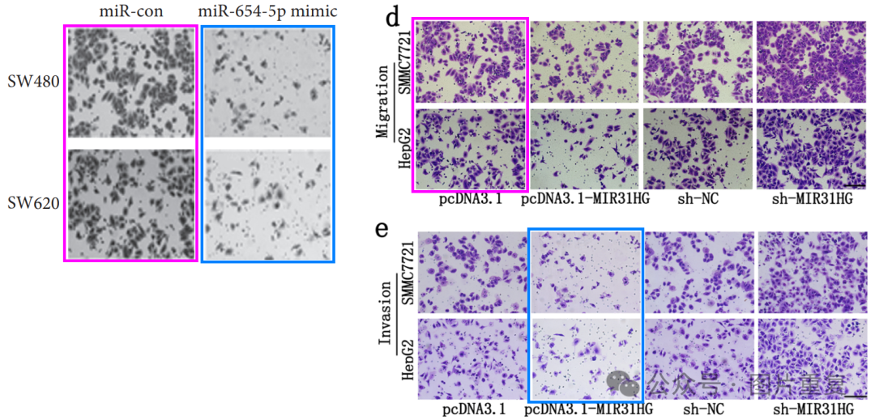

*[above]* Fig 3d from Huang et al; from *[below]* the present Fig 2d.

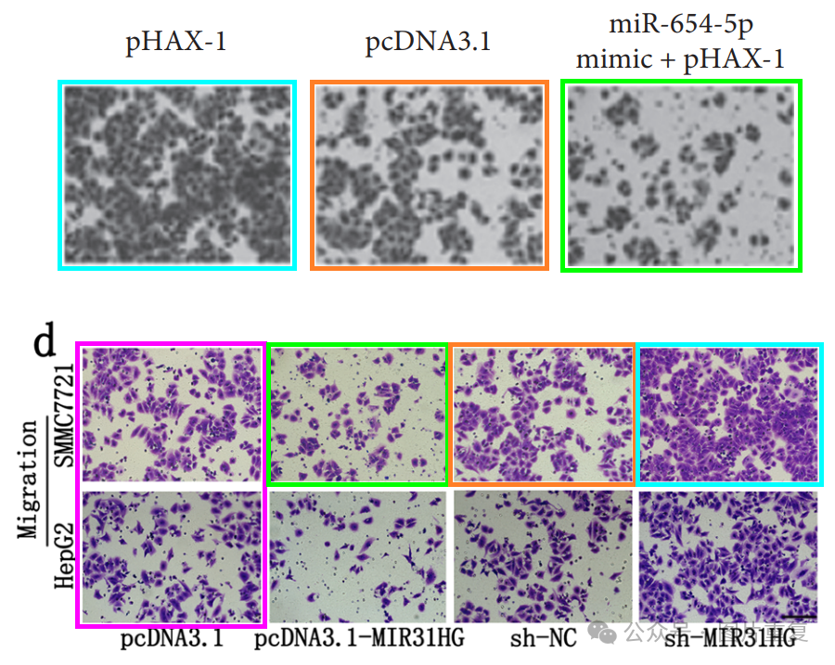

Figs 1d, 3c from Huang et al.

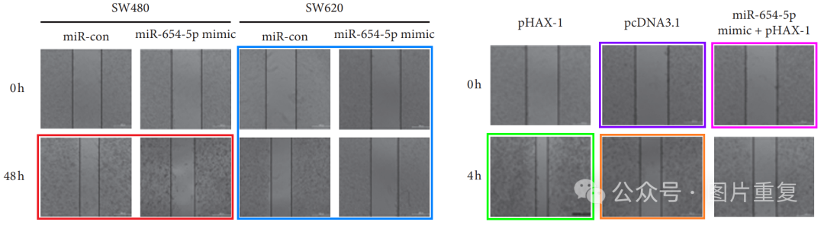

From the present Figs 2c, 4f.

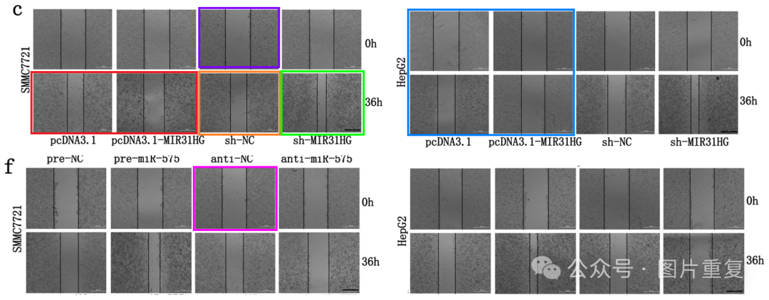

**#3Hoya Camphorifolia**

**11 month ago**

Another appropriation.

* *[above]*

 Fig 3B from "Long noncoding RNA OIP5-AS1 promotes the progression of oral squamous cell carcinoma via regulating miR-338-3p/NRP1 axis" (Li et al 2019).

* *[below]*

 Fig 4h, flipped through 180 deg for ease of comparison.

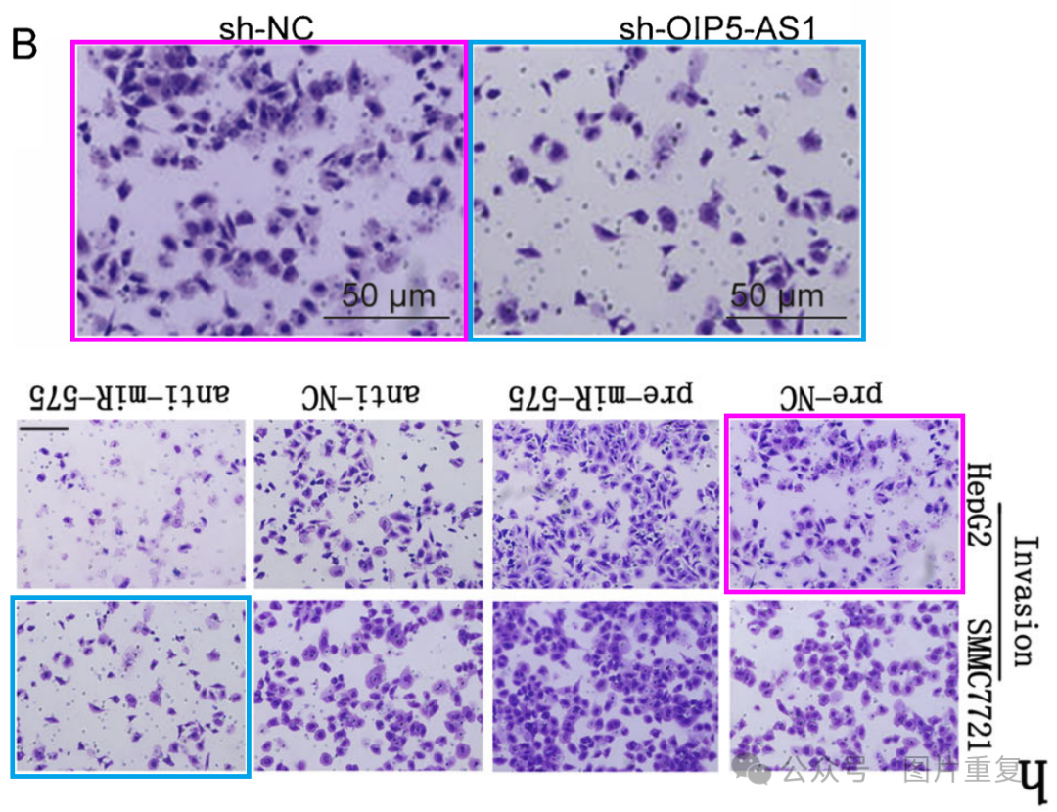

**#4Hua Tang (author)**

**10 month ago**

#3 We are not aware of the use of our data results in other papers, and we would like to thank you for your reminder.

#2 We are not aware of the use of our data results in other papers, and we would like to thank you for your reminder.

#1 I greatly appreciate your valuable feedback and have drawn our attention to the errors in our article. Unfortunately, during the image capture process, we encountered an error in grouping and naming Transwell images, and overlooked the verification process. When selecting representative images from countless image data, incorrect images are placed in the original manuscript. But this does not affect the legend, results, and conclusion of the article. We have now redone and renamed all Transwell experiments, carefully checked the images to prevent misuse, and resubmitted all Transwell experimental results to the journal. But we are not aware of the use of our data results in other papers, and we would like to thank you for your reminder.

**#5Hoya Camphorifolia**

**11 day ago**

Retracted 25 February 2025.

The Editor-in-Chief has retracted this article. After publication, concerns were raised regarding highly similar images in the figures, specifically:

* Fig. 4g SMMC7721 pre-NC image appears to overlap with Fig. 6d SMMC7721 sh-MIR31HG+anti-miR-575;
* Fig. 4h SMMC7721 pre-NC image appears to overlap with Fig. 6e SMMC7721 pcDNA3.1-MIR31HG+pre-miR-575.

The authors checked their data and found that in Fig. 2c, SMMC7721 pcDNA3.1-MIR31HG and sh-MIR31HG 0h images were the same, and Fig. 2c HepG2 pcDNA3.1-MIR31HG 36h and Fig. 4f HepG2 anti-NC 0h images originated from the same sample. Further checks by the Publisher have also identified a potential error in Fig. 6e, where HepG2 sh-MIR31HG+anti-miR-575 and pcDNA3.1+pre-NC images appear to originate from the same sample.

The authors requested a Correction and provided the original image files and cell line authentication documents. However, the STR profiling results of the cell lines used in the in vitro and in vivo experiments this study revealed that the SMMC7721 and L-02 cell lines were contaminated with HeLa cervical cancer cells, making them an unsuitable model for liver cancer. This partially undermines the main conclusions of the article, which are specific to hepatocellular carcinoma.

The Editor-in-Chief therefore no longer has confidence in the presented data and conclusions of this artilcle.

Shaoying Yan and Hua Tang disagree with this retraction. None of the other authors have responded to any correspondence from the Publisher about this retraction.