[厦门大学知名附属医院论文图片重复](https://mp.weixin.qq.com/s?__biz=Mzg5MTg0MDc4NQ==&mid=2247493112&idx=2&sn=00c52158301fc4b34ff2feb4b3c23ae0&chksm=cef7b973b25607ae954839bd0f567dc1ebd954eabcb0f396cdca1f80a2575c4d083ec886b4f5&scene=126&sessionid=1741972085)

原创  Figure[图片重复](javascript:void(0);)2025-03-08 08:18:27广东

MicroRNA-18 facilitates the stemness of gastric cancer by downregulating HMGB3 though targeting Meis2

**Bioengineered (2022)**

**PMID:**35416122

**DOI:**10.1080/21655979.2022.2062529

**AUTHORS**

**Yingjun Zhang1,Weijian Lin2,Weiping Jiang1,Zhenfa Wang2**

**AFFILIATIONS**

1Oncology Department of Radiotherapy, Zhongshan Hospital of Xiamen University, Xiamen, Fujian China

2Department of Gastrointestinal Surgery, Zhongshan Hospital of Xiamen University, Xiamen, Fujian, China

**#1René Aquarius**

**1 month ago**

Dear authors,

We found unexpected overlap between a figure presented in this study and a figure presented in another study (see enclosed image below).

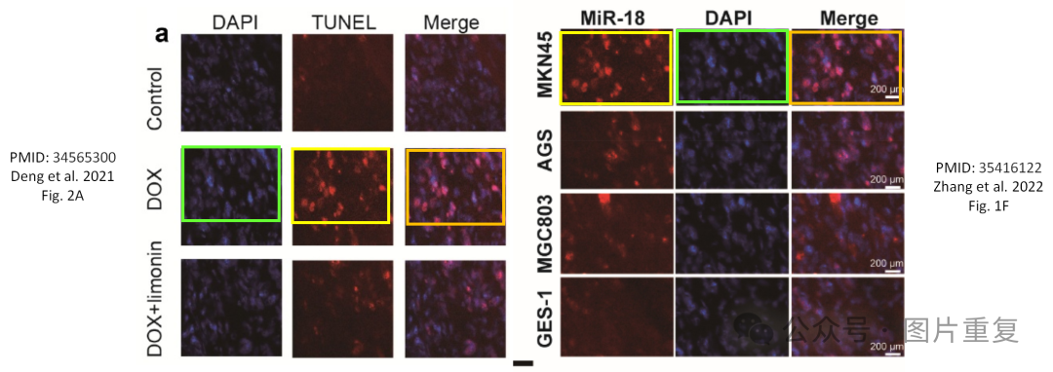The following papers are affected:

Paper 1: https://pubmed.ncbi.nlm.nih.gov/34565300/

Paper 2: https://pubmed.ncbi.nlm.nih.gov/35416122/

We will notify the publisher to resolve these issues.

Kind regards,

Rene Aquarius