[中山大学公共卫生学院知名CDC论文图片重复](https://mp.weixin.qq.com/s?__biz=Mzg5MTg0MDc4NQ==&mid=2247493112&idx=1&sn=5b4fa30272d503a3d910686becc91bcc&chksm=ce5adca33a77f2d705b9e33791936077e15fdd1c0afb856dd0c2a9e831493af1c383ef1f3d15&scene=126&sessionid=1741972085)

原创  F[图片重复](javascript:void(0);)2025-03-08 08:18:27广东

3′3-Diindolylmethane inhibits migration, invasion and metastasis of hepatocellular carcinoma by suppressing FAK signaling

**Oncotarget (2015)**

**PMID:**26068982

**DOI:**10.18632/oncotarget.4196

**AUTHORS**

**Wen-Xue Li1,Li-Ping Chen2,Min-Ying Sun1,Jun-Tao Li1,Hua-Zhang Liu1,Wei Zhu1**

**AFFILIATIONS**

1Dearpartmant of Toxicology, Guangzhou Center for Disease Control and Prevention, Guangzhou, China

2Faculty of Toxicology, School of Public Health, Sun Yet-sen University, Guangzhou, China

#### Author response

#### 1 day ago

**#1Sholto David**

**2 month ago**

**Figure 7**: Unexpected overlap, identified and annotated with red rectangles by ImageTwin.ai

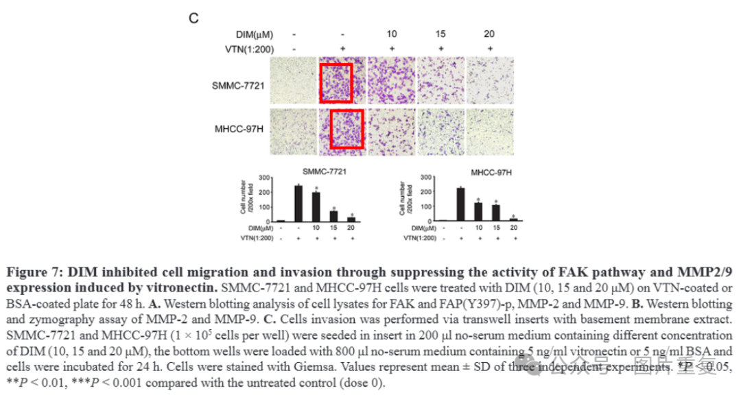Would the authors please check and comment?

**#2Sholto David 2 month ago**

Also see **Figure 5D** and **Figure 3D**:

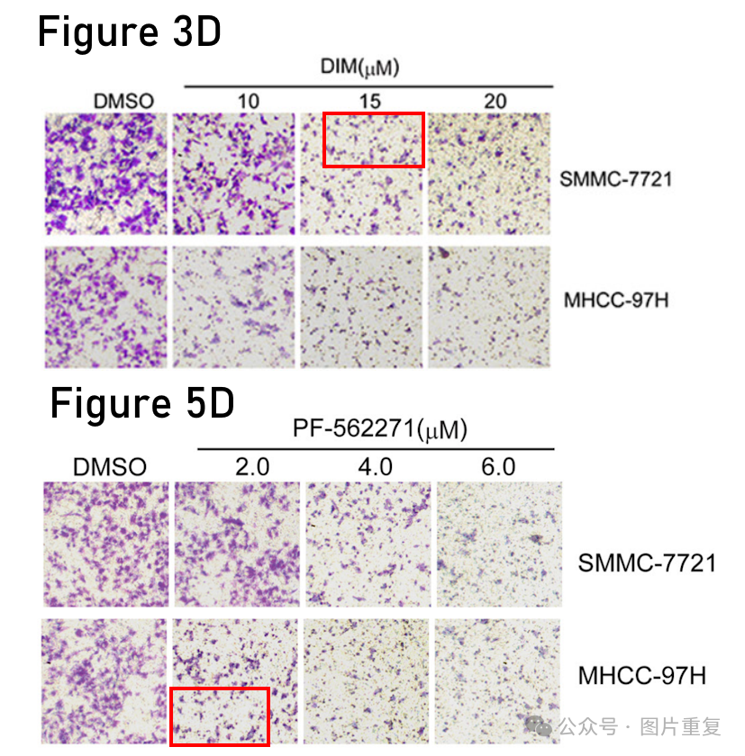

#3**Epithemia Zebra**

**14 day ago**

Much more similar than expected. Similarities detected by ImageTwin.

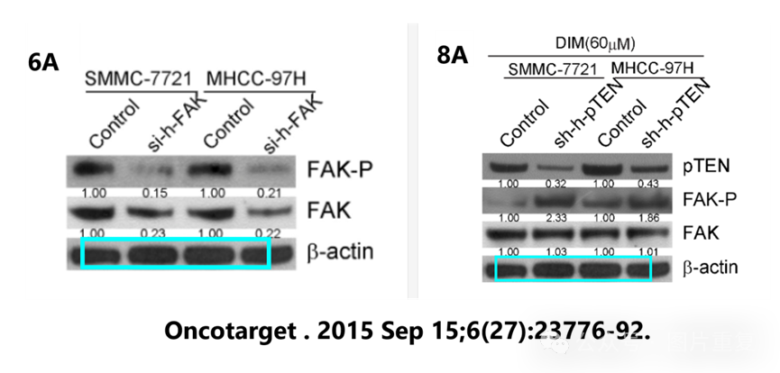

**#4Wen-Xue Li (author)**

**1 day ago**

Dear Professor, We appreciate your insightful observation and thank you for bringing this matter to our attention. Following a comprehensive review, we have identified the oversight that occurred during the image synthesis process, and we sincerely regret this mistake. We have reached out to the editor of the journal to rectify this issue. We appreciate your diligence in identifying these errors and helping us maintain the integrity of our research. Thank you once again for your careful review and constructive feedback. Best regards Wenxue Li