[海南医科大学知名团队论文图片重复](https://mp.weixin.qq.com/s?__biz=Mzg5MTg0MDc4NQ==&mid=2247493098&idx=1&sn=fd63efc9ac5f484bba7d70a61fb78a31&chksm=ce734bfa88caa964c02164833fa9d95a151503f9186fc7104900b98e1489f9e9c32603170080&scene=126&sessionid=1741972085)

原创  Fu[图片重复](javascript:void(0);)2025-03-07 09:14:34广东

**miR?181a?5p inhibits the proliferation and invasion of drug?resistant glioblastoma cells by targeting F?box protein 11 expression**

**Oncology Letters (2020)**

**PMID:**32968457

**DOI:**10.3892/ol.2020.12098

**AUTHORS**

**Xueyan Wen1,Songrong Li1,Mengchan Guo1,Hongzhan Liao1,Yongmin Chen1,Xi Kuang1,Xiaoping Liao1,Lin Ma1,Qifu Li1**

**AFFILIATIONS**

1Department of Neurology, The First Affiliated Hospital of Hainan Medical University, Haikou, Hainan 570102, P.R. China

**#1Penicillium Isariiforme**

**1 month ago**

Much more similar than expected. Similarities detected by ImageTwin.

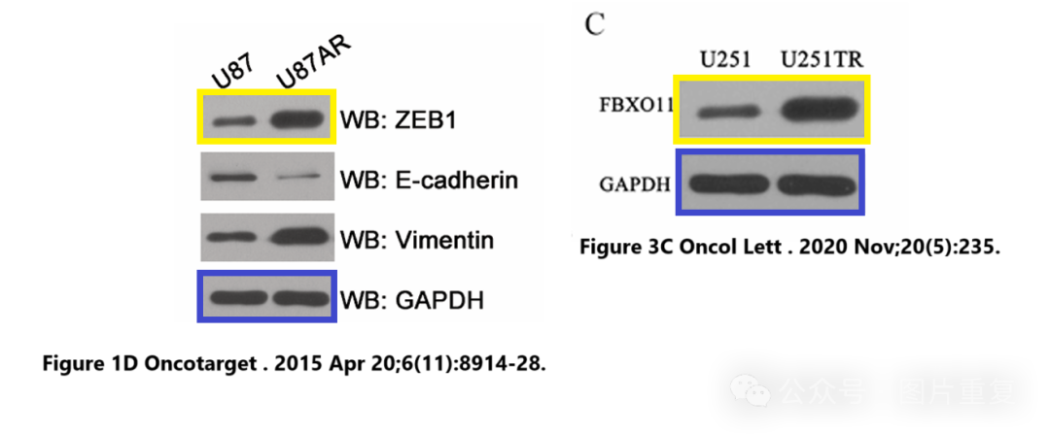

**#2Hoya Camphorifolia 6 hours ago Corrected**5 March 2025.

Following the publication of the above article, an interested reader drew to the authors’ attention that the western blot data (both the control GAPDH and the FBXO11 protein bands) in Fig. 3C on p. 6 were strikingly similar to data which had previously appeared in an article published in the journal Oncotarget, albeit one of the authors (Hongzhan Liao) was featured as an author on both papers. After having re?examined their original data, the authors realized that the wrong data had inadvertently been included in this figure part. The revised version of Fig. 4, now featuring the correct data for the GAPDH and the FBXO11 experiments in Fig. 3C, is shown on the next page. Note that the errors made in assembling this figure did not affect the overall conclusions reported in the paper. All the authors agree with the publication of this corrigendum, and are grateful to the Editor of Oncology Letters for allowing them the opportunity to publish this. The authors also apologize to the readership for any inconvenience caused.

[#论文](https://mp.weixin.qq.com/mp/appmsgalbum?__biz=Mzg5MTg0MDc4NQ==&action=getalbum&album_id=2546994047612895232#wechat_redirect)[#查重系统](https://mp.weixin.qq.com/mp/appmsgalbum?__biz=Mzg5MTg0MDc4NQ==&action=getalbum&album_id=3076605976766332935#wechat_redirect)[#图片重复](https://mp.weixin.qq.com/mp/appmsgalbum?__biz=Mzg5MTg0MDc4NQ==&action=getalbum&album_id=2546994047780667392#wechat_redirect)