[广东海洋大学知名团队论文图片重复](https://mp.weixin.qq.com/s?__biz=Mzg5MTg0MDc4NQ==&mid=2247493098&idx=2&sn=c27efd56dd8f36019a48941a86960806&chksm=ce95d47d926212d486f9b4c6df59f13eeb1d76e0a21612ee53bf30fb3e3ebee102935e762d3f&scene=126&sessionid=1741972085)

原创  F[图片重复](javascript:void(0);)2025-03-07 09:14:34广东

**Solid phase synthesis of oxidized sodium alginate-tobramycin conjugate and its application for infected wound healing**

**Carbohydrate Polymers (2022)**

**PMID:**35988976

**DOI:**10.1016/j.carbpol.2022.119843

**AUTHORS**

**Limei Liang1,Tao Liu2,Qianqian Ouyang3,Sidong Li1,Chengpeng Li4**

**AFFILIATIONS**

1School of Chemistry and Environmental Science, Guangdong Ocean University, Zhanjiang 524088, PR China.

2Department of Otolaryngology Head and Neck Surgery, Guangdong Provincial People's Hospital, Guangdong Academy of Medical Sciences, Guangzhou 510080, PR China.

3Marine Biomedical Research Institute, the Key Lab of Zhanjiang for R&D Marine Microbial Resources in the Beibu Gulf Rim, Guangdong Medical University, Zhanjiang 524023, PR China.

4School of Chemistry and Environmental Science, Guangdong Ocean University, Zhanjiang 524088, PR China. Electronic address: .

**#1Archasia Belfragei 18 hours ago**

Figure 5 contains two identical petri-dishes for different conditions at day 15

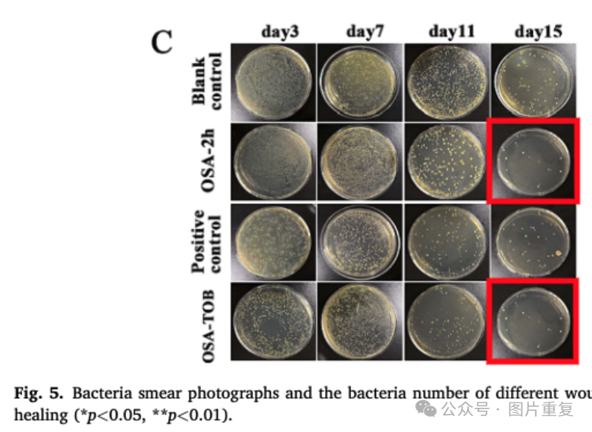

(Detected with the help of ImageTwin.ai)

* Archasia Belfragei

[#图片重复](https://mp.weixin.qq.com/mp/appmsgalbum?__biz=Mzg5MTg0MDc4NQ==&action=getalbum&album_id=2546994047780667392#wechat_redirect)[#广东海洋大学](https://mp.weixin.qq.com/mp/appmsgalbum?__biz=Mzg5MTg0MDc4NQ==&action=getalbum&album_id=3887577755763818497#wechat_redirect)[#论文](https://mp.weixin.qq.com/mp/appmsgalbum?__biz=Mzg5MTg0MDc4NQ==&action=getalbum&album_id=2546994047612895232#wechat_redirect)